ECAMP One Page Extended Abstract Template

(Title Should Be Centred 14 pt Bold Type, with Title Case Formatting – Elements and Acronyms Should Be Capitalized)

Author name(s) [10-point type, centred, bolded]
Author’s affiliation and full address (8-point type, centred, italicized)

Dominique Vernhet¹, Reinhard Dörner², John Doe^{1,2}
1. Institut des NanoSciences de Paris, Université Pierre et Marie Curie, 4 place Jussieu, 75252 Paris Cedex 05, France
2. Institut für Kernphysik, J. W. Goethe-Universität, Max-von-Laue-Str. 1, 60438 Frankfurt am Main, Germany

This is a sample document format for the one page extended abstract for submissions to the 12th European Conference on Atoms Molecules and Photons (ECAMP12). Although this document is provided in Microsoft Word format, the paper to be uploaded must be in PDF format. Paper size should be A4 format (210 mm x 297 mm). Margins should be set for a 2.5 cm top, bottom, left, and right. For text fonts: use only 10pt Times (roman, bold or italic), and Symbol. Sans Serif Fonts such as Arial can be used in Figures. Include all equations, drawings, figures and references within the one page limit. Avoid asterisks, acknowledgements, job descriptions or footnotes. Do not add page numbers.
Please be concise in your presentation, highlighting what is novel and original about your submission. Simple equations should be included in-line wherever possible, whereas more complex expressions should be centred and numbered if there are several. Figures should be relevant to the submission and preferably centred as shown below. They should be placed as close as possible to where they are mentioned in the text. Placing subfigures side-by-side is a convenient way to include multiple results within the one page limit. The figures must be greyscale. Figure captions should be centred beneath figures and in an 8-point font. Figure captions should be indented 1 cm on both sides and justified on both right and left sides.

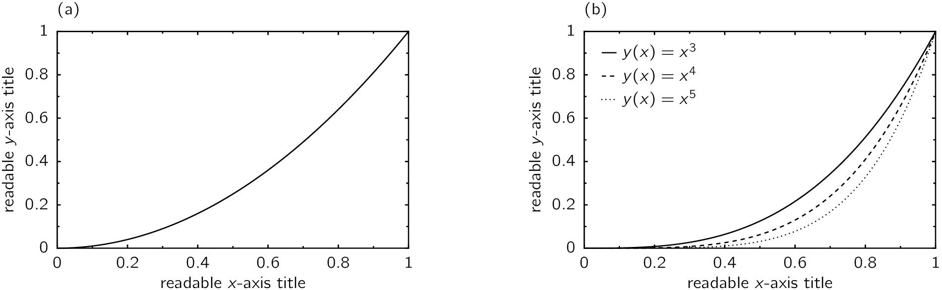

Fig. 1 The abbreviation “Fig.” with number should appear first (in bold) followed by the figure caption.

References should appear at the end of the article in the order in which they are referenced in the body of the paper. The font should be 8 point, and the references should be aligned left. Authors are listed first, followed by the full title in italic, the journal’s title abbreviation, the volume number in bold, page number, and the year in parentheses. Within the main text, references should be designated by a number in brackets [1], and they should precede a comma or period [2]. Two references cited at once should be included together [2,3], separated by a comma, while three or more consecutive references should be indicated by the bounding numbers and a dash [1–3].
References
[1] Dominique Vernhet, Reinhard Dörner, and John Doe, Reference Example for the Extended Abstract Template of the 12th European Conference on Atoms Molecules and Photons, Phys. Rev. Lett. 123, 123456 (2000).
[2] Dominique Vernhet and Reinhard Dörner, Another Example, Science 123, 1234 (2000).
[3] John Doe, Yet Another Example, Nature Phys. 123, 1234 (2000).

